Press release – for immediate distribution

FIVE REASONS WHY THE GLOBAL FOOD AND DRINK INDUSTRY IS SUPPORTING THE SUSTAINABLE AGRICULTURE REVOLUTION
Sustainable Agriculture Initiative Platform partners with Global Forum for Innovations in Agriculture for next year’s Abu Dhabi-based event

Abu Dhabi, UAE, September 11 2014: With the Global Forum for Innovations in Agriculture (GFIA) today revealing the Sustainable Agriculture Initiative (SAI) Platform as ‘Sustainable Agriculture Partner’ for next year’s GFIA, to be held 9-10 March 2015 in Abu Dhabi, we take a look at why this major network of global food and drink companies is teaming up with the influential forum, and what both are hoping to gain from the partnership.

- SECURING THE SUPPLY CHAIN

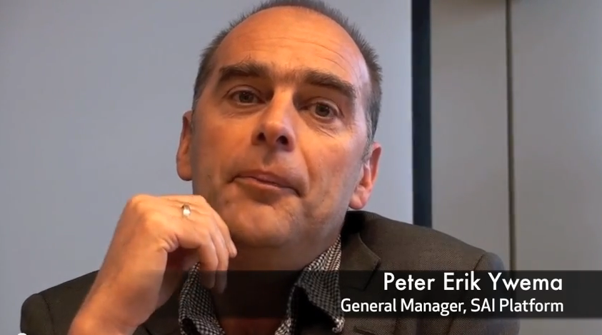
Peter Erik Ywema on why SAI Platform was set up – click image to view video

The Sustainable Agriculture Initiative (SAI) Platform was set up in 2002 by Nestlé, Unilever and Danone, and is the main global food and drink industry initiative aimed at supporting the development and implementation of sustainable agriculture practices. SAI Platform now counts over 60 members, including other industry leaders such as Mars, Kellogg’s, Anhauser-Busch InBev and Coca-Cola.

As the companies SAI Platform represents include many of the world’s biggest purchasers of agricultural raw material, the organisation is in a unique position to understand the importance of cultivating sustainable agriculture practices throughout the food chain:

“SAI Platform’s sheer existence is all about developing pre-competitive collaboration between buyers of agricultural raw materials and their suppliers. They [the companies we represent] are increasingly aware that it is in their interest to help agriculture become more sustainable and resilient. Extending this collaboration to an important forum such as GFIA, aiming at those same objectives, is a natural elaboration of this role,” explained Peter-Erik Ywema, General Manager, SAI Platform.

- KNOWLEDGE SHARING IS VITAL


Bill Gates delivers a video address for GFIA 2014 – click image to view video

With global agriculture currently witnessing an exciting series of developments, from the use of drones to wireless sensors and subsurface drip irrigation, it is vital that these innovations are made accessible and affordable to those working on the ground.

Events like GFIA provide the ideal platform for major agribusinesses and food and drink industry representatives from across the globe to share ideas, research findings and best practices with key stakeholders. A prime example of this is post-harvest losses - with studies suggesting that 1/3 of the world’s agricultural produce is wasted, next year’s GFIA will feature a Post-Harvest Losses Initiative that will run in conjunction with the main event.

“According to the United Nations the global population reached seven billion on 31 October 2011 – it is predicted to exceed nine billion by 2050. We must encourage more key agricultural decision makers to engage in the exchange of ideas that takes place at events like GFIA if we are to keep a world of nine billion people free of hunger,” said Mark Beaumont, GFIA Project Director.

- AGRICULTURE MUST BE CLIMATE SMART


A changing climate could severely impact on the global agriculture industry

The timing of SAI Platform’s decision to partner with GFIA is important, as next year’s event is to have a particularly strong focus on Climate Smart Agriculture and will showcase ‘triple win’ technologies that can help achieve food security, mitigate the effects of climate change and promote adaptability to the vagaries of a changing climate.

With the global food and drink industry increasingly susceptible to shortfalls in the supply of raw materials exacerbated by changes in weather patterns, notably rising temperatures and less predictable precipitation events, this partnership between SAI Platform and GFIA will help ensure that the industry is fully aware of new scientific research and how it can be utilised to ensure the continued efficient production of safe, high quality agricultural products in a way that protects and improves the natural environment.

“We need to make sure that practical solutions to complex production and supply chain issues are available to farmers and farming communities around the world,” said Beaumont.

- THE BEST WAY TO PREDICT THE FUTURE IS TO INVENT IT

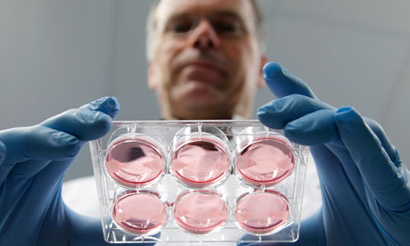
Dr Mark Post, scientist behind the Google-funded lab burger, was one of GFIA 2014’s Keynote Speakers

Necessity is the mother of invention, as the saying goes. Yet it is also the mother of innovation. As the global population continues to grow and the demand for food and water resources increases exponentially, new methods of production are essential in order to keep pace with demand and ensure a sustainable supply of raw materials for the global food and drink industry as represented by SAI Platform.

As a profoundly influential showcase for innovations in sustainable agriculture, GFIA shines a spotlight on the new technologies that are driving the future of agriculture across the globe. At this year’s event the innovations on show included: burgers grown in laboratories, urban farming in the form of elevated gardens and ‘film farming,’ a minimum-water technology in which plants are cultivated on a hydro-membrane composed of water-soluble polymer and hydrogel.

“We need to make sure that the innovations we are seeing across the agricultural supply chain are able to be easily and rapidly implemented. They must reach beyond the research laboratory and be of tangible benefit to producers of raw materials,” continued Beaumont.

- WE’RE ALL IN THIS TOGETHER

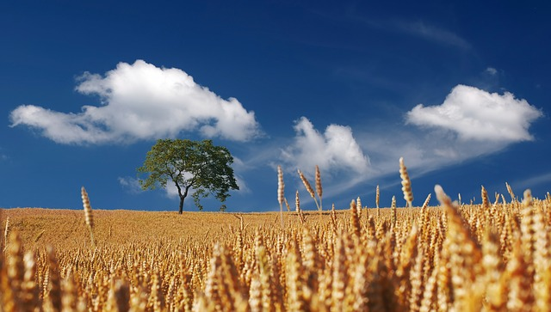
Cooperation is vital to keep pace with the world’s rapidly growing demand for food

In today’s fully interdependent globalised food supply chain, everything from agricultural raw materials and energy consumption to weather patterns and water supply is interrelated. A shortfall of raw materials in one part of the world will ripple out to affect the whole supply chain. As such, a sustainable agriculture sector that protects and improves the social and economic conditions of farmers, their employees and local communities, and safeguards the health and welfare of all farmed species is vital to all.

While competition is a necessary part of the global food and drink industry, partnership and collaboration, as fostered by SAI Platform and facilitated by GFIA, is essential to ensure that we are able to feed the world’s rapidly increasing population. For Ywema the issue boils down to a basic need shared by all: “if food companies do not have access to high quality raw materials in the right volumes, they cannot produce.”

And if the food and drink companies cannot produce, the consequences may be catastrophic. We are, ultimately, all in this together.

For more information on GFIA 2015 and to submit an innovation please go to http://www.innovationsinagriculture.com/, or contact Mark Beaumont at markbeaumont@orielme.com

<ENDS>

About GFIA 2015
Held March 9-10, 2015, under the Patronage of H.H. Sheikh Mansour Bin Zayed Al Nayhan, Deputy Prime Minister and Minister of Presidential Affairs of the UAE, the Global Forum for Innovations in Agriculture (GFIA) will be the world’s largest showcase of innovations in sustainable agriculture.

With the key theme of ‘driving innovation for an agricultural revolution,’ GFIA will highlight the sustainable agriculture initiatives being planned and deployed around the world, facilitate knowledge transfer and demonstrate available investment opportunities. The GFIA agenda was designed by a steering committee of 20 international experts in the fields of academia, R&D, science, industry and investment.

The GFIA programme includes:
• Exhibition and conference: keynote sessions, panel discussions and 150 innovation presentations.
• Incubator zone: a low-cost space for entrepreneurs to showcase their ideas and prototypes.
• Innovation Zone: display of working models of some of the most inspiring innovations in agriculture today.
• Technical tours to a range of sustainable agriculture projects in the UAE
• GCC Farmer Focus: a dedicated programme to educate GCC farmers on the benefits of sustainable agriculture
• NGO Zone: dedicated area for NGOs, development agencies and charitable foundations to meet and share ideas across sectors
• Collaboration & Research Centre: A space for universities and research organisations to share research and explore new areas of collaboration
• MENA Country Showcase pavilions: Official country pavilions where expertise, major projects, research and investment opportunities will be showcased

For more information on GFIA, please contact:
Rebecca McConnell
r.mcconnell@turretme.com
+971 50 234 6547

About the Sustainable Agriculture Initiative (SAI) Platform
SAI Platform is the global industry initiative helping food and drink companies to achieve sustainable production and source agricultural raw materials.
www.saiplatform.org

For more information on the SAI Platform please contact
Peter-Erik Ywema
General Manager
M: +31 651223350
E: peywema@saiplatform.org

